**Project Report On**

Women Safety App (“RedEye”)

**Submitted to**

**Information Technology Department**

**Year:- 2015-16**



**INFORMATION TECHNOLOGYDEPARTMENT**

**DR.S.&S.S.GHANDHY COLLEGE OFENGINERING & TECHNOLOGYSURAT**

**GUJARAT TECHNOLOGY UNIVERSITY**

**DR. S. & S. S. GHANDHY COLLEGE OF**

**ENGINERING & TECHNOLOGY**

**SURAT**



**PROJECT REPORT ON**

**“Women Safety App”(“RedEye”)**

**SUBMITED TO**

**INFORMATION TECHNOLOGY DEPARTMENT**

**YEAR:- 2015-16**

**GUIDED BY:- SUBMITED BY:**

MR.MAHESH RAGHVANI Patel Roshni (136120316041)

Kansara Aditi (136120316017)

Chippa Bhupat (136120316010

**DR.S.&S. S.GHANDHY COLLEGE OF ENGINERING & TECHNOLOGY**

**SURAT**

**CERTIFICATE**



**THIs IS TO CERTIFY THAT Patel Roshni, Kansara Aditi & Chppa Bhupat HAVING ENROLLMENT NO.136120316041, 136120316017 & 136120316010 HAVE COMPLETED IDP PROJECT WORK HAVING TITLE “Women safety app (RedEye)” THEY HAVE UNDER GONE THE PROCESS OF MANAGEMENT INDUSTRY DEFINE UNITS, LITERATURE SURVEY AND PROBLEM DEFINITION.**

**\**

**Index**

* **Project Profile**

**Chap-1 : Abstract**

* **Modules**
* **Advantages**
* **Limitations**
* **Future Scope**

**Chap-2: Specification**

**Chap-3: Scope of Project**

* **Problem Identification**
* **Detail Summary**
* **Expected Output**

**Chap-4: Requirement Analysis**

* **Problem Solving Techniques**
* **Project Life Cycle Model**

**Chap-5: Organization Chart**

**Chap-6: Software Requirement Specification**

**Chap-7: E-R Diagram**

**Chap-8: UML**

* **Use Case Diagram**
* **Class Diagram**
* **Sequence Diagram**
* **Activity Diagram**

**Chap-9: Data Dictionary**

**Chap-10: Advantages & Limitations**

**Chap-11: Future Enhancement**

**Chap-12: Bibliography**

Project Profile

* **Project Profile**

**Project Name:** RedEye-Women Safety App

**Type of Application:** Android Application

**Project Description:** This system is basically developed for women safety, in which there are 3 entities user, police & admin .The main goal of the system is to manage all the manual operations through a web based portal.

**Team Size:** 3 member

**Front End:** Android , Java, XML

**Back End:** MYSQL & SQLLITE

**Tools used:** Android Studio

Abstract

This is an android app that will help to reduce the crime rate related to girls. Girls can use this app for their security purpose. This app also provide the tutorials for defense, and also police crime places to provide security.

* **Description:**

This app is to secure the Indian street for our daughters, sister, mother, children, friends and all the women who are out their working in school, collage, offices, bus stands, shops, malls, train, and so on. This is an effective women safety app ensuring the women security. Just at the press of the button, near and dear ones will know the location. Women need not to worry all the time about their security.

* **Modules:**
  + Admin
  + Tutorials
  + User
* **Admin:**
  + - Login
    - Database Management
    - Crime History
    - Map History
* **Tutorials:**
  + - Defence Techniques
    - Defence Weapons
* **User:**
  + - Login
    - Register
    - User Details
    - Panic Button
* **Emergency Contacts:**
  + - Police Station Contacts
    - Favorite Contacts
* **Advantages:**
  + Emergency Alert
  + Finding Location using GPS & Internet
  + Search nearby police station.
  + Capture the last location.
  + Sending message to added emergency numbers
  + Police can determine the crime rate.
* **Limitation:**
* Information stored in database is static
* Internet connection is required.
* **Future Scope:**
* In future, we may link this app with more police stations.
* Information stored in database will be dynamic.

specifications

* **Introduction to Tools**
* **Front End:**
  + Android
  + Java
  + Xml
* **Back End:**
* SQLite
* **Tools:**
* Android Studio 1.0
* **Front End Tool:**
* **Android :**

Android is a software stack for mobile devices that includes an operating system, middleware and key applications. The Android SDK provides the tools and APIs necessary to begin developing applications on the Android platform using the Java programming language.

* **Android Architecture :**

The following diagram shows the major components of the Android operating system. Each section is described in more detail below.

* **Application :**

Android will ship with a set of core applications including an email client, SMS program, calendar, maps, browser, contacts, and others. All applications are written using the Java programming language.

* **Application Framework :**

By providing an open development platform, Android offers developers the ability to build extremely rich and innovative applications. Developers are free to take advantage of the device hardware, access location information, run background services, set alarms, add notifications to the status bar, and much, much more.

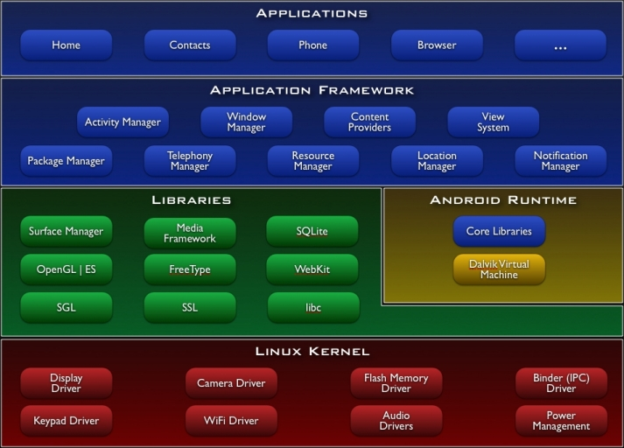

Developers have full access to the same framework APIs used by the core applications. The application architecture is designed to simplify the reuse of components; any application can publish its capabilities and any other application may then make use of those capabilities (subject to security constraints enforced by the framework). This same mechanism allows components to be replaced by the user.

Underlying all applications is a set of services and systems, including:

**✓** A rich and extensible set of [**Views**](http://developer.android.com/resources/tutorials/views/index.html) that can be used to build an application, including lists, grids, text boxes, buttons, and even an embeddable web browser.

**✓** [**Content Providers**](http://developer.android.com/guide/topics/providers/content-providers.html) that enable applications to access data from other applications (such as Contacts), or to share their own data.

**✓** A [**Resource Manager**](http://developer.android.com/guide/topics/resources/resources-i18n.html), providing access to non-code resources such as localized strings, graphics, and layout files.

**✓** A [**Notification Manager**](http://developer.android.com/reference/android/app/NotificationManager.html) that enables all applications to display custom alerts in the status bar.

**✓** An [**Activity Manager**](http://developer.android.com/reference/android/app/Activity.html)that manages the lifecycle of applications and provides a common navigation back stack.

* **Libraries :**

Android includes a set of C/C++ libraries used by various components of the Android system. These capabilities are exposed to developers through the Android application framework. Some of the core libraries are listed below:

**✓ System C library** - a BSD-derived implementation of the standard C system library (libc), tuned for embedded Linux-based devices

**✓ Media Libraries** - based on PacketVideo's OpenCORE; the libraries support playback and recording of many popular audio and video formats, as well as static image files, including MPEG4, H.264, MP3, AAC, AMR, JPG, and PNG.

**✓ Surface Manager** - manages access to the display subsystem and seamlessly composites 2D and 3D graphic layers from multiple applications

**✓ LibWebCore** - a modern web browser engine which powers both the Android browser and an embeddable web view

**✓ SGL** - the underlying 2D graphics engine

**✓ 3D libraries** - an implementation based on OpenGL ES 1.0 APIs; the libraries use either hardware 3D acceleration (where available) or the included, highly optimized 3D software rasterizer.

**✓ FreeType** - bitmap and vector font rendering

**✓ SQLite**- a powerful and lightweight relational database engine available to all application.

* **Android Runtimes :**

Android includes a set of core libraries that provides most of the functionality available in the core libraries of the Java programming language.

Every Android application runs in its own process, with its own instance of the Dalvik virtual machine. Dalvik has been written so that a device can run multiple VMs efficiently. The Dalvik VM executes files in the Dalvik Executable (.dex) format which is optimized for minimal memory footprint. The VM is register-based, and runs classes compiled by a Java language compiler that have been transformed into the .dex format by the included "dx" tool.

The Dalvik VM relies on the Linux kernel for underlying functionality such as threading and low-level memory management.

* **Linux Kernel :**

Android relies on Linux version 2.6 for core system services such as security, memory management, process management, network stack, and driver model. The kernel also acts as an abstraction layer between the hardware and the rest of the software stack.

* **JAVA:**

Java is a general purpose computer programming language that is object oriented and specifically designed to have as few implementation dependencies as possible. It is intended to let application developers “Write once, Run anywhere”. Java was originally developed by James Gosling at Sun Microsystems and released in 1995.

* **XML:**

Extensible Markup Language is a markup language that defines a set of rules for encoding documents in a format which is both human readable and machine readable. The design goals of XML emphasize simplicity, generality and usability across the internet.

* **Back End Tool:**

**MYSQL:**

* **What is MySQL?**
* MYSQL is a Database server.
* MYSQL is ideal for both small and large applications.
* MYSQL supports standard SQL.
* MYSQL complies on a number of platforms.
* MYSQL is free to download and use.
* MYSQL is a database management system.
* MYSQL is a relational database management system.
* MYSQL software is Open Source.
* The MYSQL Database Server is very fast, reliable, and easy to use.
* MYSQL Server works in client/server or embedded systems.
* A large amount of contributed MySQL software is available.
* **History of MYSQL :**

We started out with the intention of using the MYSQL database system to connect to our tables using our own fast low-level (ISAM) routines. However, after some testing, we came to the conclusion that MYSQL was not fast enough or flexible enough for our needs. This resulted in a new SQL interface to our database but with almost the same API interface as MYSQL. This API was designed to allow third-party code that was written for use with MYSQL to be ported easily for use with MYSQL.

The name of the MYSQL Dolphin (our logo) is “ Sakila,” which was chosen from a huge list of names suggested by users in our “Name the Dolphin” contest. The winning name was submitted by Ambrose Twebaze, an Open Source software developer from Swaziland, Africa. According to Ambrose, the feminine name Sakila has its roots in SiSwati, the local language of Swaziland. Sakila is also the name of a town in Arusha, Tanzania, near Ambrose's country of origin, Uganda.

* **Why Choose MYSQL?**

As was the case with many other open source projects, MYSQL was first created by

Someone who needed a better tool to get a specific job done. Monty **Widenius** and

David Axmark started out with another open source project(MSQL), but found that

it lacked some features that they needed.

* **Portability:** MYSQL runs on almost every flavor of Unix, as well as WindowsAnd

MacOS X. You can obtain binaries or source code for the MYSQL Server as well as

The tools that access it. More ports of the software become available every day.

* **Speed:** Using techniques such as efficient indexing mechanisms, in memory temporary

Tables, and highly optimized join algorithms, MYSQL executes most queries much

Faster than most other database systems.

* **Scalability:** Because of its modularity and its flexibility in configuration, MYSQL can run

in systems varying in size from embedded systems to large multiprocessor Unix servers

hosting databases with tens of millions of records. This scalability also allows you to run

a copy of MySQL on a developer-class machine, and later use the same database system

on a larger machine in production.

* **Flexibility:** MYSQL lets you choose the table types you need to meet your software’s

Requirements, ranging from in-memory heap tables, fast on-disk MYISAM tables, merge

tables that group together other sets of tables to form larger “virtual” tables, and transaction-

safe tables such as InnoDB. MYSQL is also very tunable and includes many parameters that

can be changed to increase performance for a given solution.

* **Ease of use:** MYSQL is easy to install and administer. While other database systems require special knowledge and training, not to mention special operating system configurations,

MYSQL can be installed in less than 10 minutes if you’ve done it before.

## SQLite:

* **What is SQLite:**
* SQLite isan Open Source database.
* SQLite supports standard relational database features like SQL syntax, transactions and prepared statements.
* SQLite is embedded into every Android device.
* Using an SQLite database in Android does not require a setup procedure or administration of the database.
* You only have to define the SQL statements for creating and updating the database
* Afterwards the database is automatically managed for you by the Android platform.
* **History of SQLite:**

D. Richard Hipp designed SQLite in the spring of 2000 while working for General Dynamics on contract with the United States Navy.Hipp was designing software used aboard guided missile destroyers, which were originally based on HP-UX with an IBM Informix database back-end. The design goals of SQLite were to allow the program to be operated without installing a database management system or requiring a database administrator. Hipp based the syntax and semantics on PostgreSQL 6.5 documentation. In August 2000, version 1.0 of SQLite was released, with storage based on [gdbm](http://en.wikipedia.org/wiki/Gdbm) (GNU Database Manager). SQLite 2.0 replaced gdbm with a custom B-tree implementation, adding support for transactions. SQLite 3.0, partially funded by America Online,added internationalization,

 manifest typing, and other major improvements.

In 2011 Hipp announced his plans to add an UnQL interface to SQLite databases and to develop UnQLite, an embeddable document-oriented database.

* **Android Studio:**

Android Studio is an integrated development environment (IDE) for developing on the Android platform .It was announced on may 16,2013 at the Google i/o conference by Google’s Product Manager, Katherine Chou. Android Studio is freely available under the Apache License 2.0.

Scope of project

**1)) Problem identification :**

Today women security is a big issue for the government in our country. The crime level increases day by day.

Women and girls have to be secure at this time. Technology needs to be improved for this purpose.

Our women empowerment app will help women and girls whenever they are out of their houses or at malls, offices, bus stands, shops and so on.

Just at the press of button, they will get emergency contacts of their near & dear ones. Police can track their locations whenever and wherever button will press. The History of that area will captured by the police, and by the ratio of crime history, police will get alert for that area. Women and girls can see the tutorials of self-defence for their empowerment.

**2)) Detail summary of Project:**

* This app is to secure Indian-street for our daughters, sisters, mother, children, friends and all the women who are out their houses.
* This is an effective women safety app ensuring the women security.
* Girls can use this app for their security. They need not to worry all the time about their security.

This app uses two main modules:

1. **Admin:**

* Login
* Database Manager
* Crime History
* Map History

Admin can login & admin will handle the whole database related to police contacts & user information. Admin also handles the crime history & map history and also make changes in it. Admin can handle the user profile and emergency contacts.

1. **User**

* Login
* Registration
* User Details
* Panic Button
* Tutorials
* First of all, all users need to sign up for this app. If they are already registered, they are already registered, they need to log in.
* Homepage will appear which will have a panic button.
* On clicking the button, a pop-up will appear which will ask for choice for contacts to send the call and message.
* There will be two choices:
* **Police Contacts:**

On clicking this choice, the call or message will be send to the nearest police station.

* **Family/Friend Contact:**

Clicking on this choice, call or message will sent to user’s family members or friends. User must add contacts to friend/family at the time of registration. User can see the tutorials of self-defence which will help them for their security. User can also see the crime history & map history. User can edit their profile. If user has any issue, there will be a FAQ for this purpose. User can make a fake call.

**3)) Expected Output:**

This app will help girls/women whenever they feel unsafe or panic. This app is for security of the women.

requirement

ANALYSIS

* **System Analysis:**
* **Requirement Specification:**

To develop any Application system, it is most important to identify the user requirement in very specific manner. Also to function properly, all interfaces of proposed system with surrounding system must be identified. The correct system is that satisfied all users requirement. Therefore it is very important to analyze the existing system and to document the software requirement specification for proposed system, which in turn provides the base for development of the proposed system.

Along with our technical training, we simultaneously started the system study and analysis. During this phase, initially we started with studying the system specification documents to understand the system and unveil the basic system elements involved.

Our project guide conducted a series of lectures to impart us the required knowledge about the system. During the lectures, we also had question and answer session at the end, which helped us to have a clear idea about the Expected system.

1. **Interviewing:**

For System The Repair Industry we interviewed personalities from management and seller without any disturbance and without wasting their valuable time. We asked the management about their expectation and requirement for the proposed system.

1. **Questionnaire:**

* How important for company to maintain the System for Repair Industry?
* Is there any existing system for managing the System for Repair Industry?
* How are you presently managing System for Repair Industry?
* Why do you need to implement System for Repair Industry?
* Which features you wish to include in the proposed system?
* Which type of interface the users require?
* Which information does management requires from System for Repair Industry?

1. **Observing:**

By discussion and questionnaire, we were able to get a lot of important information for proposed system. We have observed that what inputs are given to their existing system and what kind of output they are getting out. We have also observed the delay and correctness of the bias of the workload and bottlenecks.

1. **Problem Solving Technique:**

* **Bottom-Up:**
  + - Bottom-up approach is a democratic and consultative style of decision making, organizational changes and leadership. In which employee participation is promoted at all levels of the organization.
    - High deployment coverage in early phases.
    - Bottom-up approach is one that works from the grassroots- from a large number\of people working together, causing a decision to aris.e from their joint involvement
    - A decision by a number of activities, students or victim of some incident to take action is bottom-up decision.
    - A bottom-up approach allows for more experimentation and a better feeling for what is needed at the bottom.
    - It is a type of information processing based on incoming data from the environment to form a perception.
* **Advantages:**

User & Business awareness of the product benefits are realized in the early phases. You can replace much manual process with early automation. You can implement password management for a large number of users. You do not have to develop custom adapters in the early phases. Your organizations broader identify management skills and understanding during the first phase

.

1. **Project life cycle model :**

* **INCREMENTAL MODEL**
  + - The incremental model combines elements of the linear sequential model with the interactive philosophy of prototyping. The incremental model, first increment is called core product. In core product basic requirements are added but some unknown supplementary features remains undelivered.
    - This core product is used by customer to evaluate the system and next increment analysis is planned to develop.
    - During first requirement analysis phase, customer and developers, specifies as many requirements as possible and prepare documentation.
    - Now a first version of product with minimal and essential feature is launched to market. Based on the feedback and experience with this version, list of additional features are added.
* This process is repeated following delivery of each increment, until the complete product is produced.
* **Advantages:**
  + Less cost and time is required to develop first increment called core product.
  + It can result in better testing, because testing each increment is likely to be easier than testing entire system.
  + Incremental funding is allowed, means only or two increments might be funded when the program starts.
  + Less risk is possible to develop the similar system represented by the increments.
* **INCREMENTAL MODEL:**

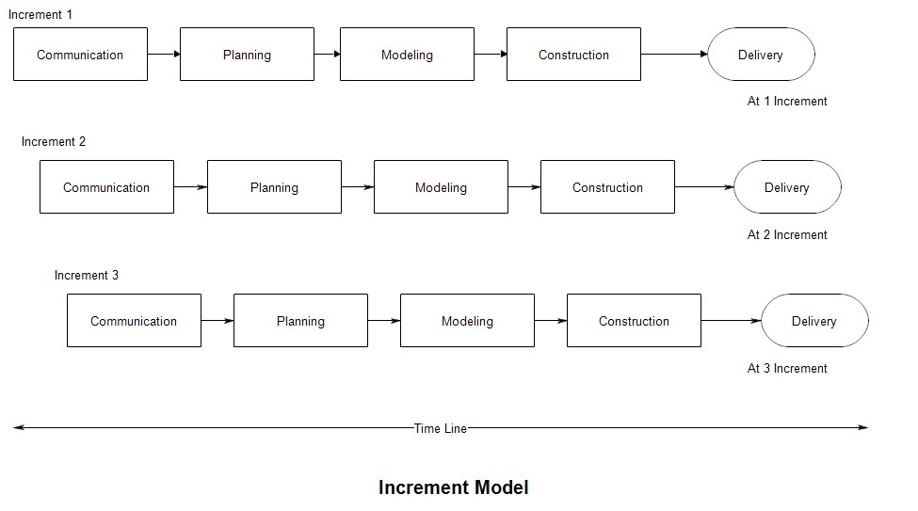

Organization chart

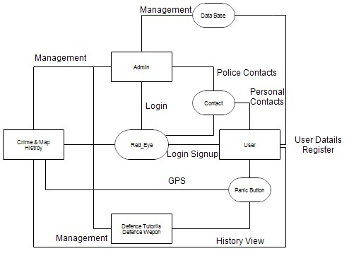

Software requirement specification

* **Business Requirements :**

RedEye app will let the girl/ women be safe and make theirself protected in these such unsafe environment. This type of apps has become basic need in this time as girl crime rate goes higher day by day. This app will help them by guiding what to do in such situation and how to be aware in unsafe places.

Product Features: Here’s the brief discussion about app features.

* Defence tutorials & motivational quotes that guide and encourage the person.
* Previous cases history that keep aware of crime techniques.
* Safe places navigation.
* On button press, delivery of message to near ones and police station of respected areas.
* Additional feature is map history. By having map history, people get aware- whether the area is safe or not. Even police will get know- whether the crime rate goes up or down.
* Simple app for carrying out your own security.
* **Context Diagram:**

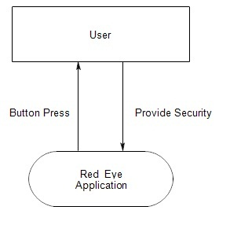

* **User Characteristics :**

There are three types of user interact with system.

* **User of mobile app**
* **Police**
* **Administrators**

Each of these three types of users has different use of the system so each of them has their own requirements.

* **Hardware Requirements :**

Since neither the mobile app nor the web portal have any direct interface.

The physical GPS is managed by the GPS application in the mobile phone & the hardware connection to the database server is managed by the underlying OS on the mobile phone.

* **Functional Requirements**

This is the most important session of SRS.

Above is the basic requirement for the app:

- Download the app

- Need of Internet

- Must have android device.

- GPS must be ON.

- User have to log in or signup.

- Button press is required to send location or message.

**Block Diagram:**

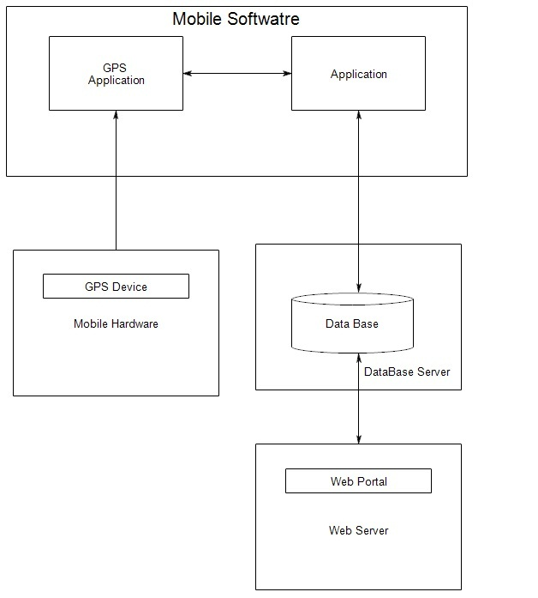

e-r diagram

* **Entity-Relationship Diagram :**

An E-R diagram is a data modeling technique that graphically illustrates an information system’s entities and the relationship between those entities.

An E-R diagram is a conceptual and representational model of data used to represent the entity framework infrastructure.

The elements of an ERD are:

* **Entities**
* **Relationships**
* **Attributes**











**Entity:**

Entity is a grouping of things with rules or data in common.

**Action: [State]**

The process or state of doing something.

**Attribute:**

Attribute is a specification that defines property of an entity.

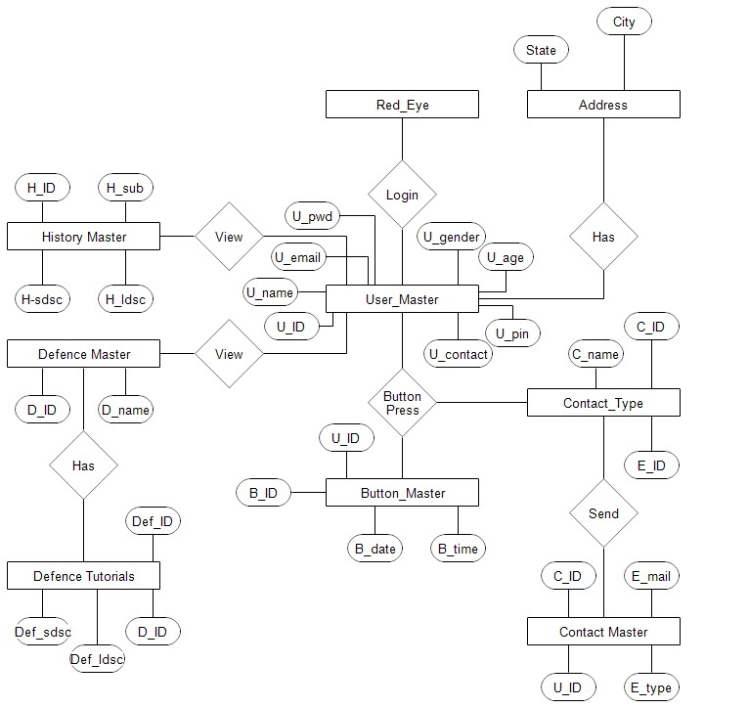

Entity-Relationship Diagram

Uml

* **WHAT IS UML?**

**UML: Unified Modeling Language**.

* UML is a modeling language, not a methodology or process.
* Developed by Grady Booch, James Rambaugh and lvar Jacobson at Rational Software.
* The UML is a general purpose, development modeling language. In the field of software engineering, that is a intended to provide standard way to visualize the design of system.
* In 2005 the UML was also published by the International Organization for standardization (ISO) as an approved ISO standard.
* UML consist such diagram:

**Use Case Diagram**

**Class Diagram**

**Sequence Diagram**

**Activity Diagram**

DIAGRams

USECASE DIAGRAM

* **USE CASE DIAGRAM:**

A use case diagram shows a set of use cases and actors (a special kind of class) and their relationships.

Use case diagram is applied to illustrate the static use case view of a system.

Use case diagram are especially important in a organizing of the system.

* **ADMIN Use Case Diagram:**

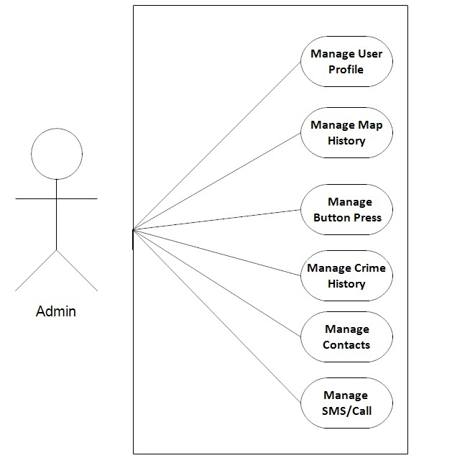

* **USER Use Case Diagram:**

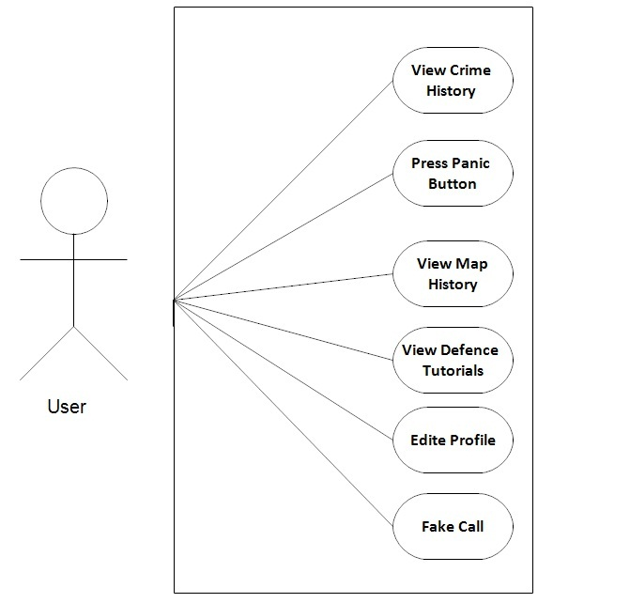

**POLICE Use Case Diagram:**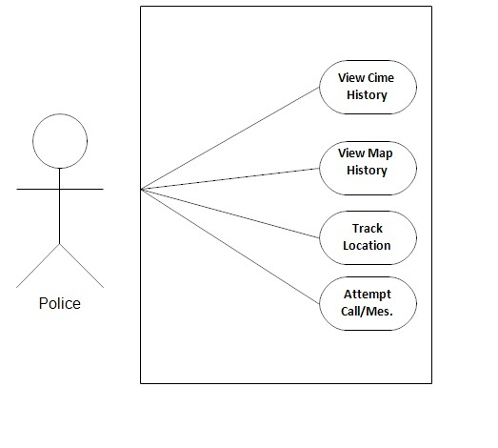

Activity diagram

* An activity diagram shows the flow from activity to within a system.
* An Activity shows a set of activities, the sequential or branching flow from activity to activity and objects that act and are acted upon.
* Activity diagram is used to illustrate the dynamic view of a system.
* Activity diagram are especially important in modeling the function of a system.
* Activity diagrams emphasize the flow of control among objects.
* 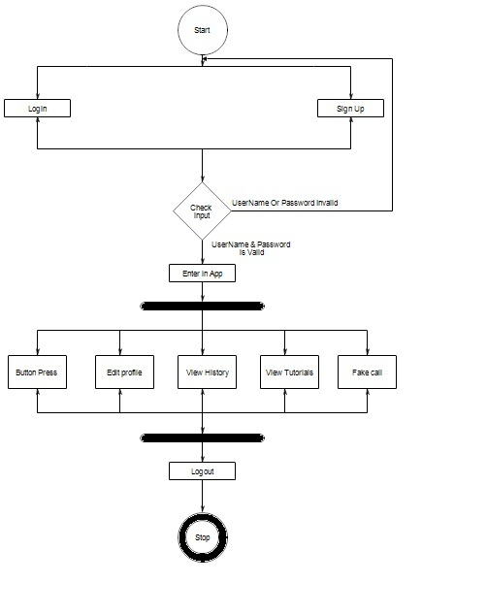

Class Diagram

* **Class Diagram:**
* A class diagram shows a set of classes interface and collaborations and their relationships.
* A class diagram is most familiar diagram found in a modeling object oriented system.
* Class diagram is used to illustrate the static design view of system.
* Class diagram that includes active classes are used to address the static process view of a system.

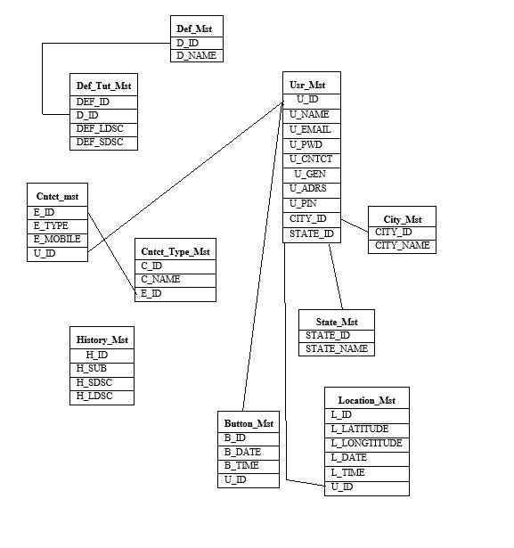

Sequence Diagram

* **Sequence diagram:**
* A sequence diagram is an interaction diagram that emphasized the time ordering of messages.
* A sequence diagram shows a set of objects and the messages sent and received by those objects.
* The objects are typically named or anonymous instances of classes but may also represent instances of other things, such as collaboration components and nodes.
* Sequence diagram is used to illustrate the dynamic view of a system.

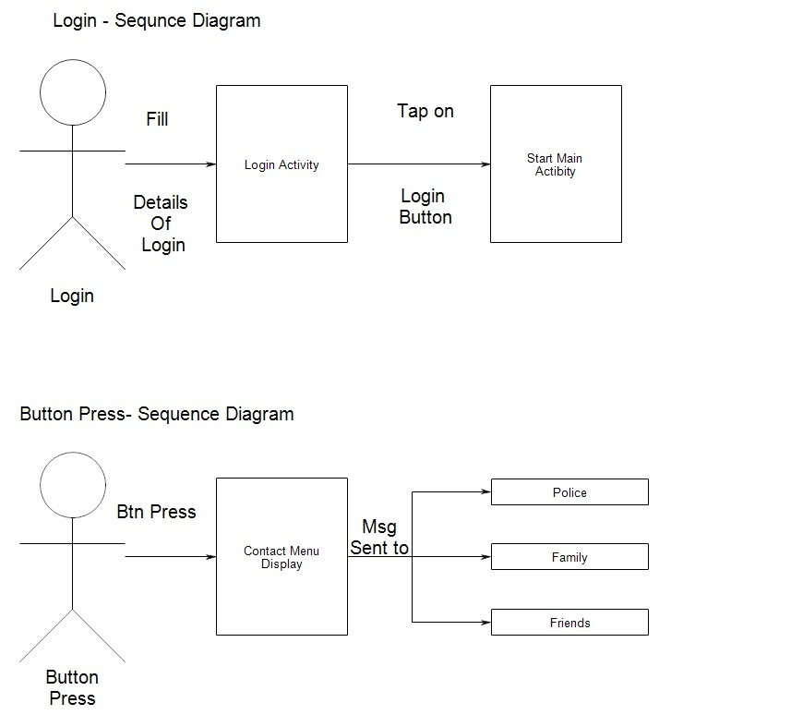

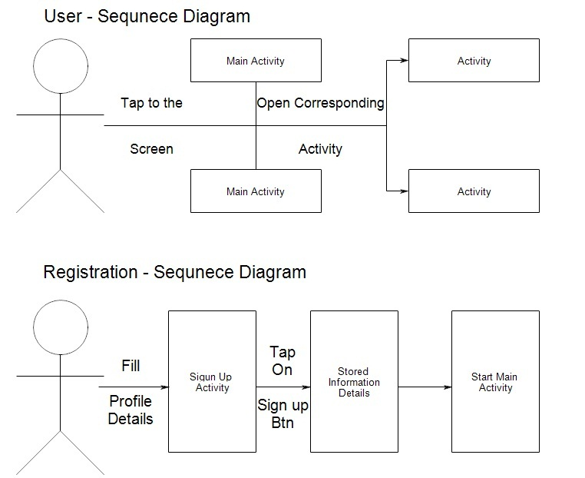

Data Dictionary

* **Data Dictionary:**

A data dictionary is a catalogue, a repository of the element system. As the name suggest, the elements center on data and they are structured to meet user requirement and organization needs. Thus, data dictionary gives the details and description of data flows, process and stores used in data flow diagram.

**Importance of Data Dictionary:-**

* To manage the details in large system.
* To communicate a common meaning for all elements.
* To document the features of the system.
* To facilitate analysis of the details in order to evaluate characteristics and determine where system change should be made.
* To locate errors and omissions in the system.

**USER_MASTER_TABLE**

|  |  |  |  |
| --- | --- | --- | --- |
| **ID** | **TYPE** | **SIZE** | **CONSTRAINTS/**  **DESCRIPTION** |
| U_ID | INT | - | PRIMARY KEY |
| U_NAME | VARCHAR | 20 |  |
| U_EMAIL | VARCHAR | 30 |  |
| U_PWD | VARCHAR | 8 |  |
| U_CNTCT | VARCHAR | 10 |  |
| U_GEN | BOOLEAN | - |  |
| U_ADRS | VARCHAR | 150 |  |
| U_PIN | INT | 6 |  |
| CITY_ID | INT | - | FOREIGN KEY |
| STATE_ID | INT | - | FOREIGN KEY |

**DEFENCE_MASTER _TABLE**

|  |  |  |  |
| --- | --- | --- | --- |
| **ID** | **TYPE** | **SIZE** | **CONSTRAINTS/**  **DESCRIPTION** |
| D_ID | INT | - | PRIMARY KEY |
| D_NAME | VARCHAR | 20 |  |

**DEFENCE_TUTORIAL_MASTER_TABLE**

|  |  |  |  |
| --- | --- | --- | --- |
| **ID** | **TYPE** | **SIZE** | **CONSTRAINTS/**  **DESCRIPTION** |
| DEF_ID | INT | - | PRIMARY KEY |
| D_ID | INT | - | FOREIGN KEY |
| DEF_LDSC | VARCHAR | - |  |
| DEF_SDSC | VARCHAR | 100 |  |

**CONTACT_MASTER_TABLE**

|  |  |  |  |
| --- | --- | --- | --- |
| **ID** | **TYPE** | **SIZE** | **CONSTRAINTS/**  **DESCRIPTION** |
| E_ID | INT | - | PRIMARY KEY |
| E_TYPE | VARCHAR | 20 |  |
| E_MOBILE | VARCHAR | 10 |  |
| U_ID | INT | - | FOREIGN KEY |

**CONTACT_TYPE_MASTER_TABLE**

|  |  |  |  |
| --- | --- | --- | --- |
| **ID** | **TYPE** | **SIZE** | **CONSTRAINTS/**  **DESCRIPTION** |
| C_ID | INT | - | PRIMARY KEY |
| C_NAME | VARCHAR | 20 |  |
| E_ID | INT | - | FOREIGN KEY |

**HISTORY_MASTER_TABLE**

|  |  |  |  |
| --- | --- | --- | --- |
| **ID** | **TYPE** | **SIZE** | **CONSTRAINTS/**  **DESCRIPTION** |
| H_ID | INT | - | PRIMARY KEY |
| H_SUB | VARCHAR | 100 |  |
| H_SDSC | VARCHAR | 100 |  |
| H_LDSC | VARCHAR | - |  |

**CITY_MASTER_TABLE**

|  |  |  |  |
| --- | --- | --- | --- |
| **ID** | **TYPE** | **SIZE** | **CONSTRAINTS/**  **DESCRIPTION** |
| CITY_ID | INT | - | PRIMARY KEY |
| CITY_NAME | VARCHAR | 20 |  |

**STATE_MASTER_TABLE**

|  |  |  |  |
| --- | --- | --- | --- |
| **ID** | **TYPE** | **SIZE** | **CONSTRAINTS/**  **DESCRIPTION** |
| STATE_ID | INT | - | PRIMARY KEY |
| STATE_NAME | VARCHAR | 20 |  |

**LOCATION_MASTER_TABLE**

|  |  |  |  |
| --- | --- | --- | --- |
| **ID** | **TYPE** | **SIZE** | **CONSTRAINTS/**  **DESCRIPTION** |
| L_ID | INT | - | PRIMARY KEY |
| L_LATITUDE | FLOAT | - |  |
| L_LONGTITUDE | FLOAT | - |  |
| L_DATE | TEXT | - |  |
| L_TIME | TEXT | - |  |
| U_ID | INT | - | FOREIGN KEY |

**BUTTON_MASTER_TABLE**

|  |  |  |  |
| --- | --- | --- | --- |
| **ID** | **TYPE** | **SIZE** | **CONSTRAINTS/**  **DESCRIPTION** |
| B_ID | INT | - | PRIMARY KEY |
| B_DATE | TEXT | - |  |
| B_TIME | TEXT | - |  |
| U_ID | INT | - | FOREIGN KEY |

Screen layouts

1. App logo :



1. Welcome screen .

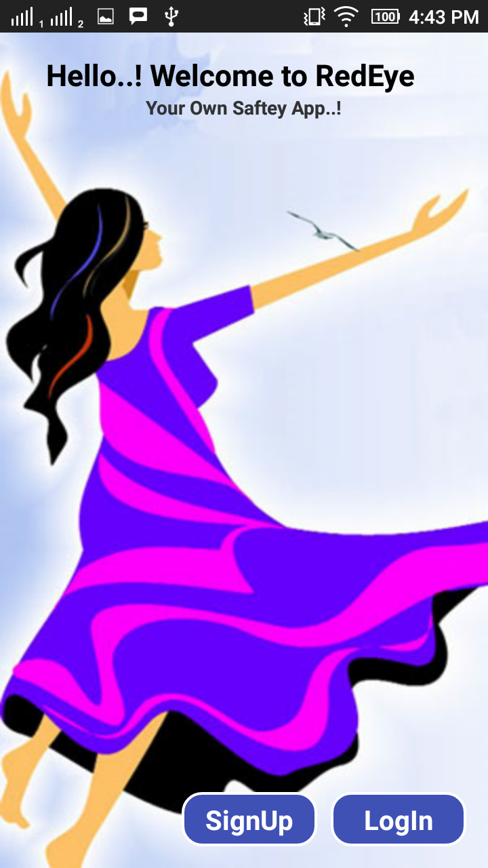

1. **This is a Login page where admin can login in site with the valid username and password.**

**Data come from admin table and check if it’s valid or not.**

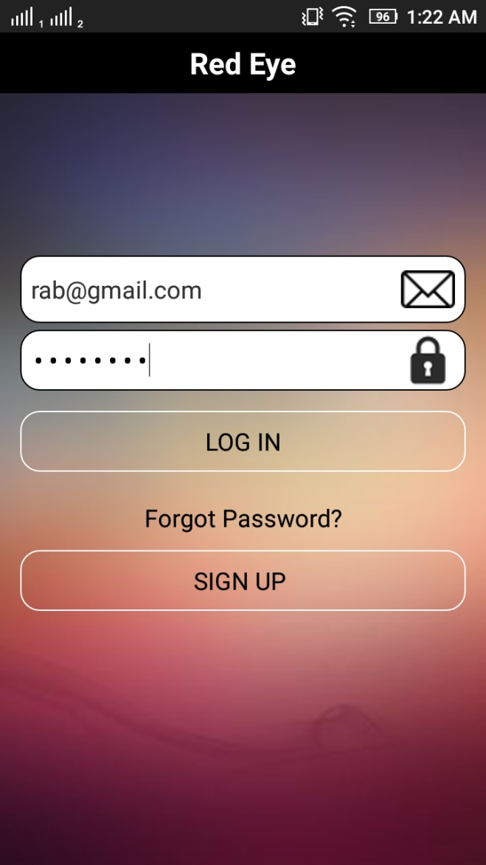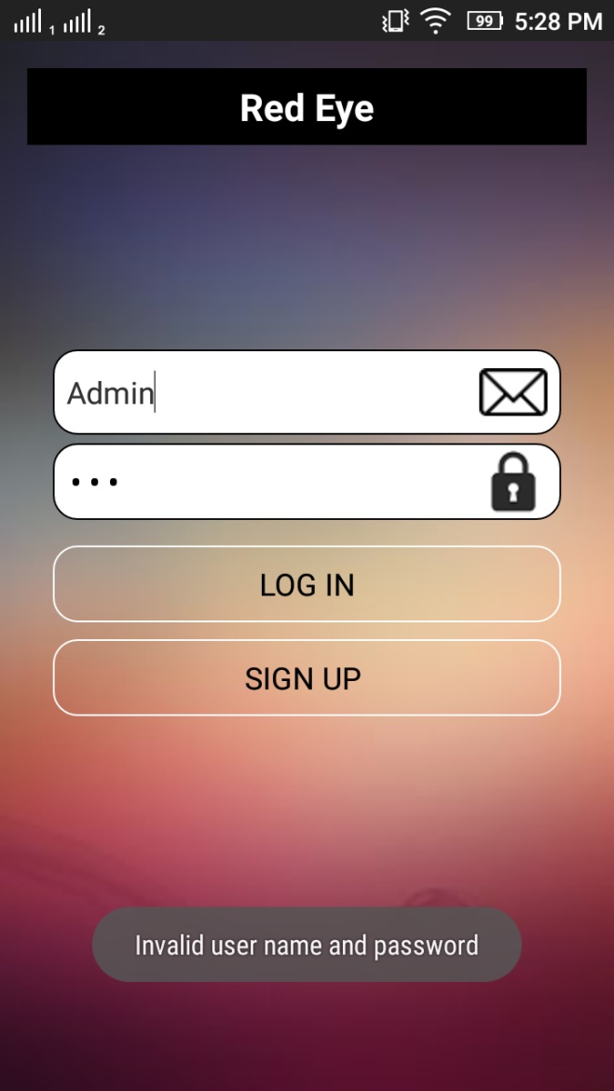

1. **This is the SignUp page where user will register for the app.**

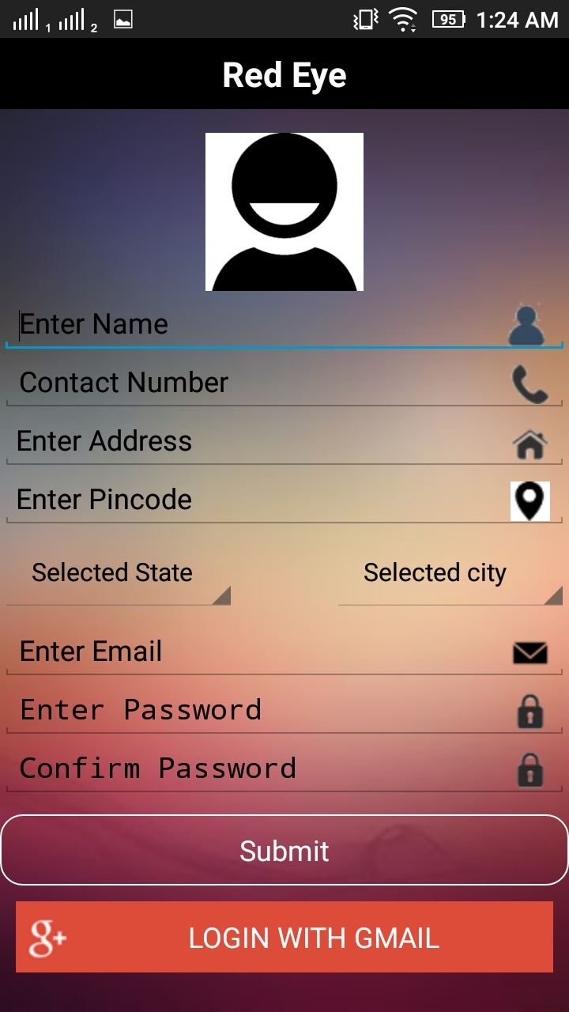

1. **Forgot Password ?**

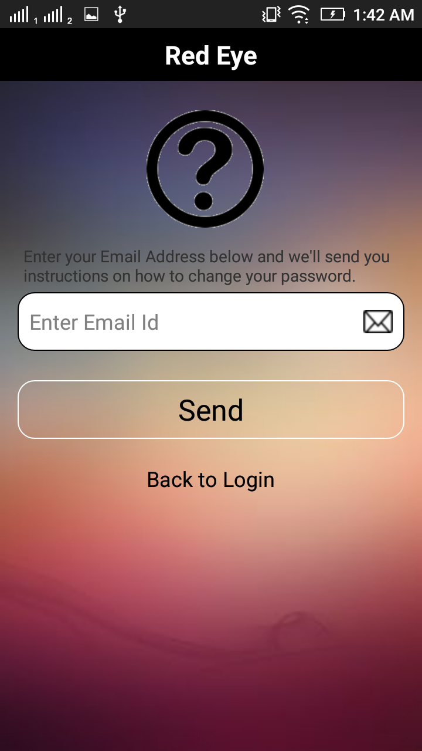

1. **Reset Your Password .**

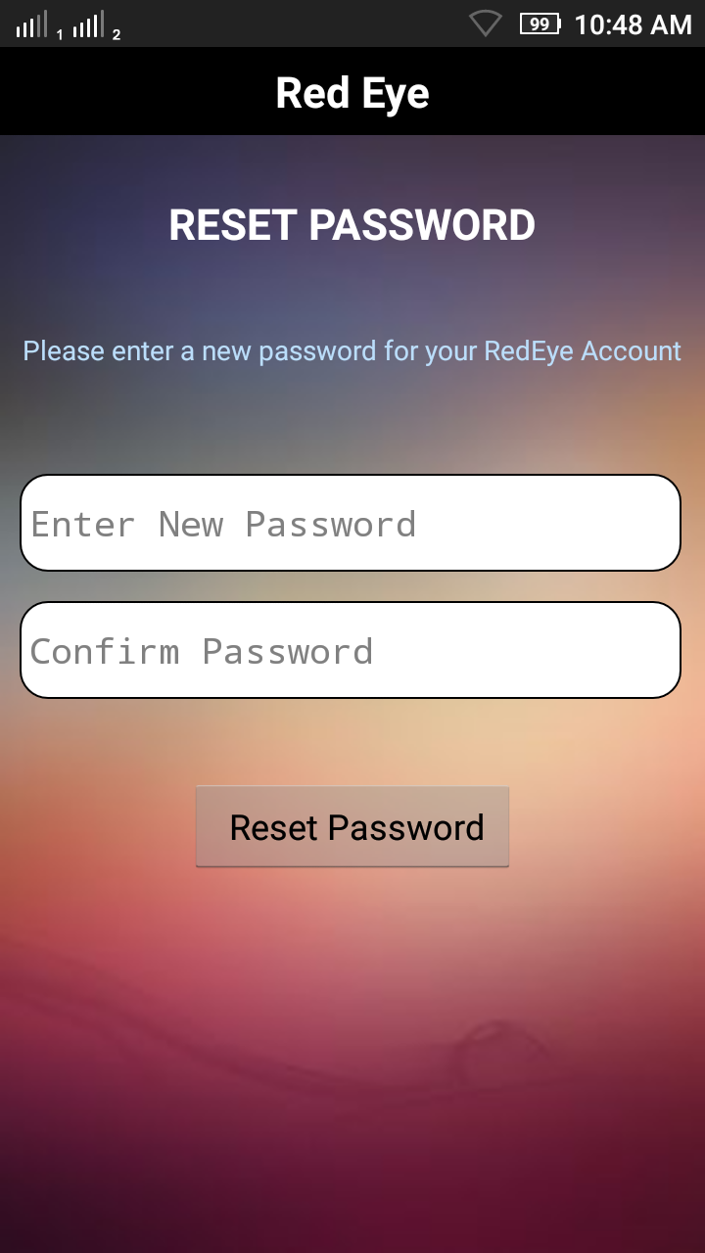

1. **Home Screen :**

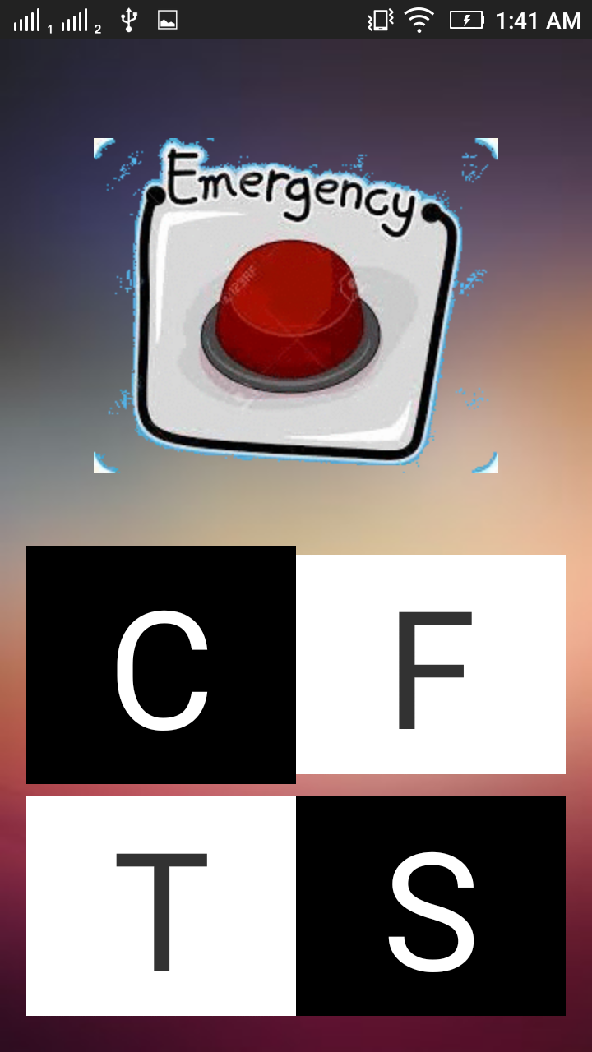

1. **Add Contacts :**

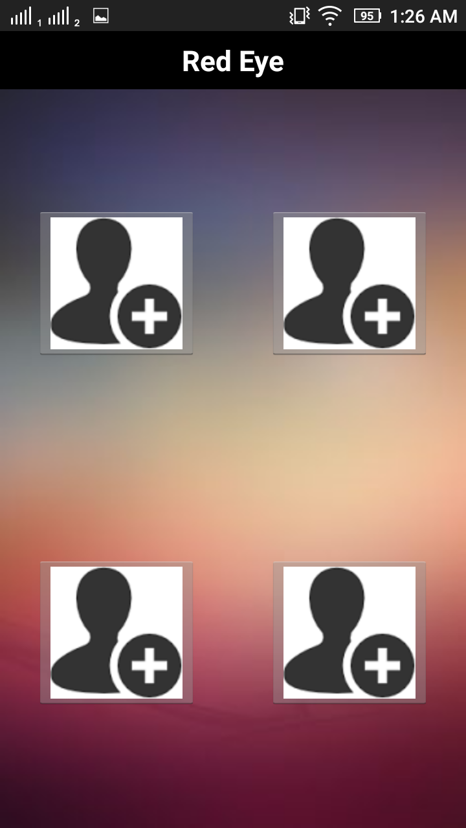

1. **Fake call :**

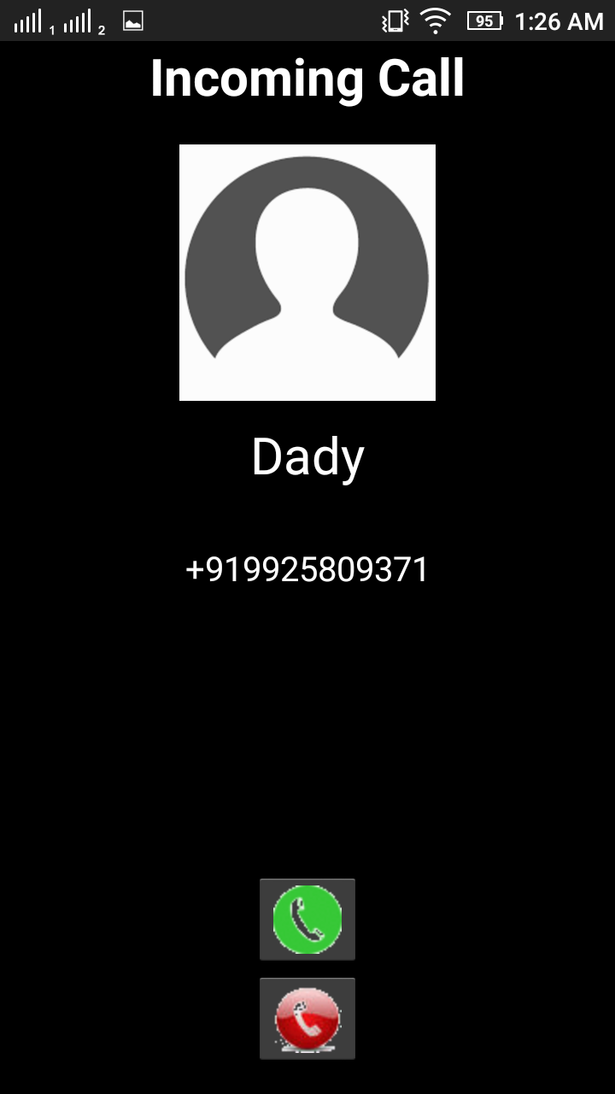

Future Enhancement

* **Future Enhancement**
* We may link this app with more police stations.
* Information stored in database will be centralized.
* Navigation to places will be added.

Advantages & limitations

* **Advantages:**
* RedEye an app that instantly connects you to your loved ones and the local police in case of emergency.
* Once installed, a user in emergency like – eve teasing, stalking, unwanted fire, road accidents etc. presses emergency button on this app, sending out alert message with her/his GPS location to local police and their pre-chosen emergency contacts at regular intervals.
* Instantly displays the emergency alert at the police control room on a city map.
* RedEye has other brilliant features too, once button is pressed :
* Emergency SMS sent to 5 contacts.
* Phone automatically goes on vibrate mode.
* Phone becomes a GPS tracking.
* Starts notification on the users phone that app is live.
* It also has features along with safety tutorials.
* **Limitations:**
* Android device is required.
* Internet is necessary.
* GPS must be ON.
* Battery Consumption

Conclusion

**Conclusion**

The app is a dedicated safety app for all those women who are out their houses. In this app, women will be able to send message in emergency to her near ones. Self-Defence tutorials will guide & encourage the women. Mainly crime history & map history will keep aware of crime level & crime rate.

Bibliography

**Web References**

* **Lunapic.com**
* **Androidhive.com**
* **Angrytools.com**
* **Stackoverflow.com**
* **Tutorialspoint.com**